ToucanTech – Demo Panel

Task 5

Solution:

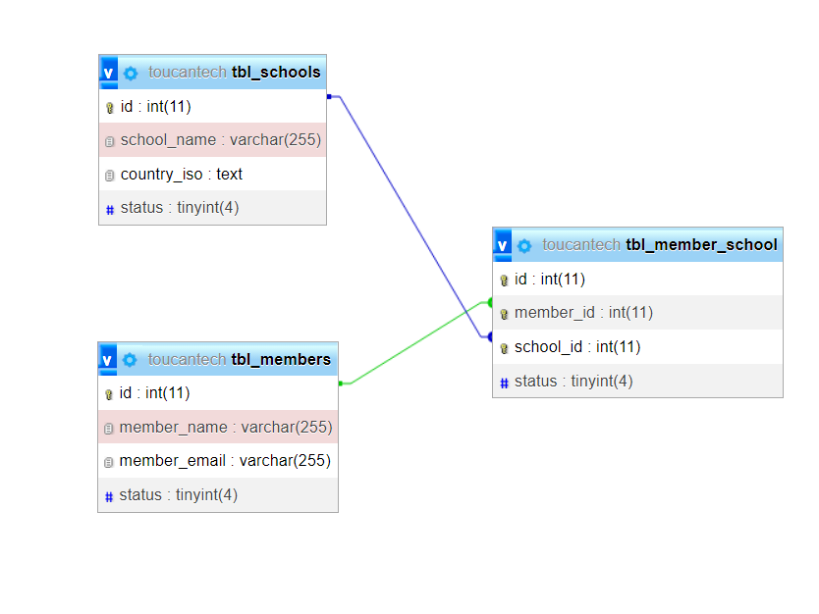

**Caption**: Relationship Diagram

This document provides an overview of the database schema for managing schools and their associated members. The database includes three main tables: tbl_schools, tbl_members and tbl_member_school. It is designed to mapping schools and their relationships with members.

**Database Schema**

**tbl_schools Table**

* Description: This table stores information about schools.

Columns

1. **id** (Primary Key):
   * Data Type: INT
   * Description: Unique identifier for each school.
2. **school_name**:
   * Data Type: VARCHAR
   * Description: The name of the school.
3. **country_iso**:
   * Data Type: TEXT
   * Description: 3 character country iso code.
4. **status**:
   * Data Type: TINYINT
   * Description: status enable/disable.

**tbl_members Table**

* Description: This table stores information about members.

Columns

1. **id** (Primary Key):
   * Data Type: INT
   * Description: Unique identifier for each member.
2. **member_name**:
   * Data Type: VARCHAR
   * Description: The name of the member.
3. **member_email**:
   * Data Type: VARCHAR
   * Description: Email address of the member.
4. **status**:
   * Data Type: TINYINT
   * Description: status enable/disable.

**tbl_member_school Table**

* Description: This table stores information about members.

Columns

1. **id** (Primary Key):
   * Data Type: INT
   * Description: Unique identifier for each member.
2. **member_id**:
   * Data Type: INT
   * Description: primary id of tbl_members.
3. **school_id**:
   * Data Type: INT
   * Description: primary id of tbl_schools
4. **status**:
   * Data Type: TINYINT
   * Description: status enable/disable.

**tbl_activity_logs Table**

* Description: This table is used to log activities related to login, logout, clients and members.

Columns

1. **id** (Primary Key):
   * Data Type: INT
   * Description: Unique identifier for each log entry.
2. **user_id**:
   * Data Type: INT
   * Description: Identifier of the user responsible for the activity (e.g., admin or staff).
3. **tbl_name**:
   * Data Type: VARCHAR
   * Description: tbl name for which the activity is added with record id.
4. **record_id**:
   * Data Type: INT
   * Description: primary id of tbl records.
5. **ip_address**:
   * Data Type: VARCHAR
   * Description: ip address of logged user.
6. **user_agent**:
   * Data Type: VARCHAR
   * Description: browser/location details of logged user
7. **action**:
   * Data Type: VARCHAR
   * Description: Description of the action whether it is ADD,EDIT,DELETE,STATUS_CHANGE etc.
8. **activity**:
   * Data Type: VARCHAR
   * Description: Additional details or information about the activity.
9. **status**:
   * Data Type: TINYINT
   * Description: status of record enable/disable.
10. **created_at**:
    * Data Type: DATE
    * Description: date of record added